Interrogative Adjectives

🔹 What Are Interrogative Adjectives?
# Source: AI Source: Provided by: [Data Path: Persons Table -> ID Column: 1, Name_En Column: Motasem Essam] -> From: [Chatgpt (GPT-4-turbo)] on [7/27/2025]
Interrogative adjectives are words used to ask questions and are always followed by a noun.
They help us ask which one, what kind, or whose.

✅ The Main Interrogative Adjectives Are:
# Source: AI Source: Provided by: [Data Path: Persons Table -> ID Column: 1, Name_En Column: Motasem Essam] -> From: [Chatgpt (GPT-4-turbo)] on [7/27/2025]
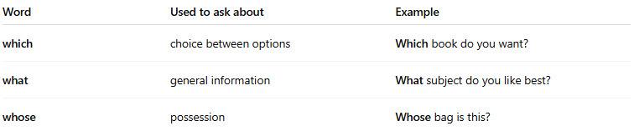
Word | Used to ask about | Example
which | choice between options | Which book do you want?
what | general information | What subject do you like best?
whose | possession | Whose bag is this?

📚 Examples in Sentences
# Source: AI Source: Provided by: [Data Path: Persons Table -> ID Column: 1, Name_En Column: Motasem Essam] -> From: [Chatgpt (GPT-4-turbo)] on [7/27/2025]
- Which movie are we watching tonight?
- What color is your car?
- Whose phone is ringing?

🧠 Key Points
# Source: AI Source: Provided by: [Data Path: Persons Table -> ID Column: 1, Name_En Column: Motasem Essam] -> From: [Chatgpt (GPT-4-turbo)] on [7/27/2025]
- An interrogative adjective must be followed by a noun.
✅ Which shirt is yours?
❌ Which is yours? (This is an interrogative pronoun, not an adjective.)

⚠️ Compare:
# Source: AI Source: Provided by: [Data Path: Persons Table -> ID Column: 1, Name_En Column: Motasem Essam] -> From: [Chatgpt (GPT-4-turbo)] on [7/27/2025]
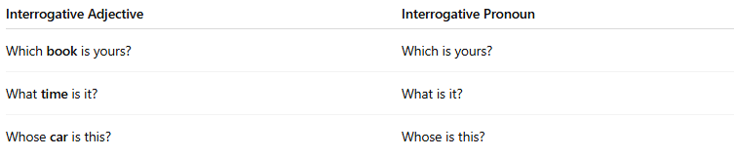
Interrogative Adjective | Interrogative Pronoun
Which book is yours? | Which is yours?
What time is it? | What is it?
Whose car is this? | Whose is this?

Interrogative Adjectives vs. Interrogative Pronouns
# Source: AI Source: Provided by: [Data Path: Persons Table -> ID Column: 1, Name_En Column: Motasem Essam] -> From: [Chatgpt (GPT-4-turbo)] on [7/27/2025]
Both interrogative adjectives and interrogative pronouns are used to ask questions, but they serve different functions in a sentence.

✅ Interrogative Adjectives
# Source: AI Source: Provided by: [Data Path: Persons Table -> ID Column: 1, Name_En Column: Motasem Essam] -> From: [Chatgpt (GPT-4-turbo)] on [7/27/2025]
- Modify a noun
- Always come before a noun
- Ask "which one?", "what kind?", or "whose?"
Examples:
- Which book is yours?
- What movie did you watch?
- Whose car is this?
✅ Here, the adjective is part of the noun phrase: "which book", "what movie", "whose car".

✅ Interrogative Pronouns
# Source: AI Source: Provided by: [Data Path: Persons Table -> ID Column: 1, Name_En Column: Motasem Essam] -> From: [Chatgpt (GPT-4-turbo)] on [7/27/2025]
- Replace a noun
- Stand alone
- Ask questions about people, things, or ownership
Examples:
- Which is yours?
- What is that?
- Whose is this?
✅ Here, the pronoun takes the place of the noun.

📊 Comparison Table
# Source: AI Source: Provided by: [Data Path: Persons Table -> ID Column: 1, Name_En Column: Motasem Essam] -> From: [Chatgpt (GPT-4-turbo)] on [7/27/2025]
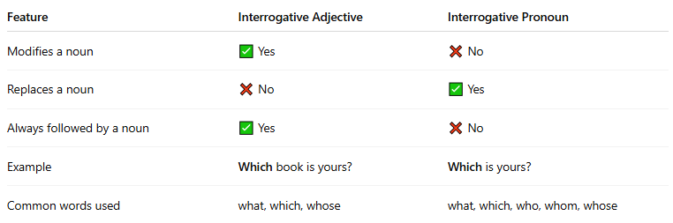
Feature | Interrogative Adjective | Interrogative Pronoun
Modifies a noun | ✅ Yes | ❌ No
Replaces a noun | ❌ No | ✅ Yes
Always followed by a noun | ✅ Yes | ❌ No
Example | Which book is yours? | Which is yours?
Common words used | what, which, whose | what, which, who, whom, whose

